Coursework Proposal: Cultural Heritage Site Management System

Module: CS107.3 - Object Oriented Programming with C#
Module Leader: Anton Jayakody
Group: C
Institution: NSBM Green University

- Team Composition
- S A Y Randhinu - Student ID: 38677
- K T Damhiru - Student ID: 38035
- W A A S H Weerasooriya - Student ID: 37910
- T O H Jinasinghe - Student ID: 38440
- H N B Hansana - Student ID: 38712
- W G C Isidhara - Student ID: 38641
- P D Weerathunga - Student ID: 37514
- N Nimjaya - Student ID: 38294
- P M L Hewawasam - Student ID: 38449

- Problem Statement

- Managing and preserving Sri Lanka's historical and archaeological sites currently relies heavily on manual tracking systems. Site managers lack a centralized platform to monitor artifact conditions, track visitor capacity, and efficiently allocate tour guides. This project will deliver a unified, interactive C# application targeting the .NET framework to solve these logistical bottlenecks, providing a localized solution for heritage site management.

- System Scope & Core Requirements

- Given the rapid development timeline, the project will focus strictly on impactful modules that demonstrate Object Oriented Programming concepts and database integration.
- Artifact Inventory (CRUD & OOP): A centralized system to log artifacts. This will utilize inheritance (ex: a base Artifact class with subclasses like Relic and Ruins) to fulfil advanced OOP criteria.
- Visitor & Tour Guide Management (Relational Database): Modules to register visitors and assign them to specific tour guides based on time and date. This will demonstrate the system's ability to handle relational data.
- Interactive Admin Dashboard: A main UI hub displaying live metrics such as total daily visitors and available guides to ensure an interactive user experience.

- Unique Innovative Features
- Smart QR Code Ticketing

- The application features an automated digital ticket generator. By using the QRCoder library, the system pulls visitor and guide data directly from the database to create a downloadable QR ticket. This provides visitors a modern privacy centred way to keep their personal details in our database temporarily rather than the conventional paper ticket experience.

- SOS Alert System

- To prioritize visitor safety, the visitor's main dashboard includes a quick-access emergency feature. If a visitor gets lost or separated from their group, they can instantly send a "Lost" alert through their interface. This automated message is immediately routed to both the system administrators and their specifically assigned guide, ensuring a rapid response and secure recovery.

- Implementation Plan

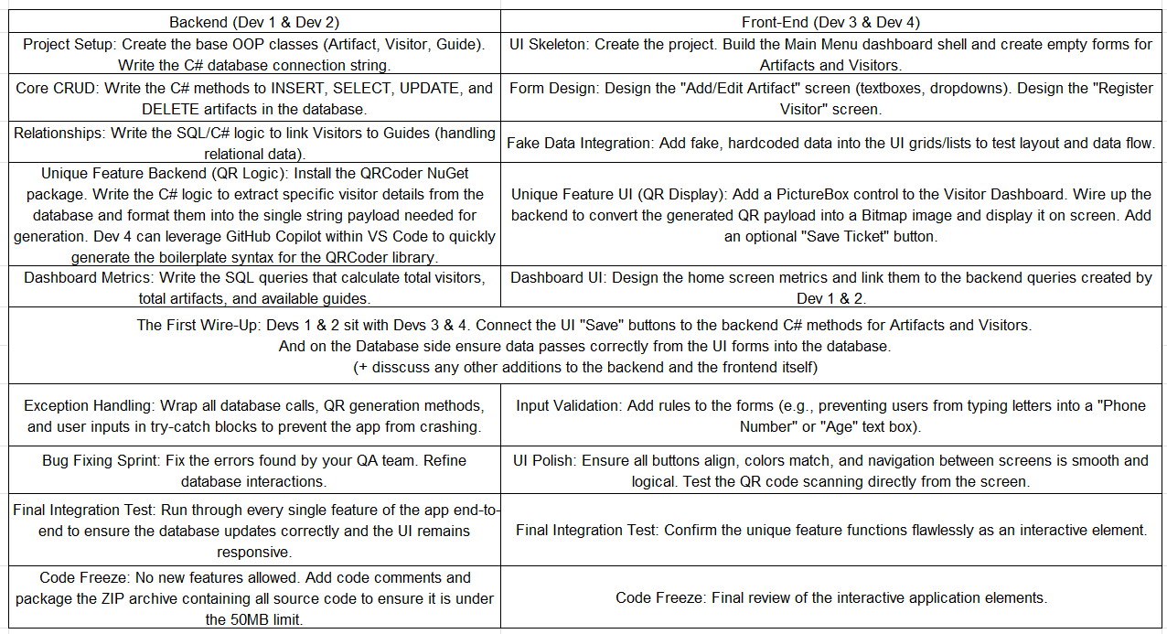
- The workload is strictly isolated between backend architecture and UI design to prevent merge conflicts, with targeted integration days.

